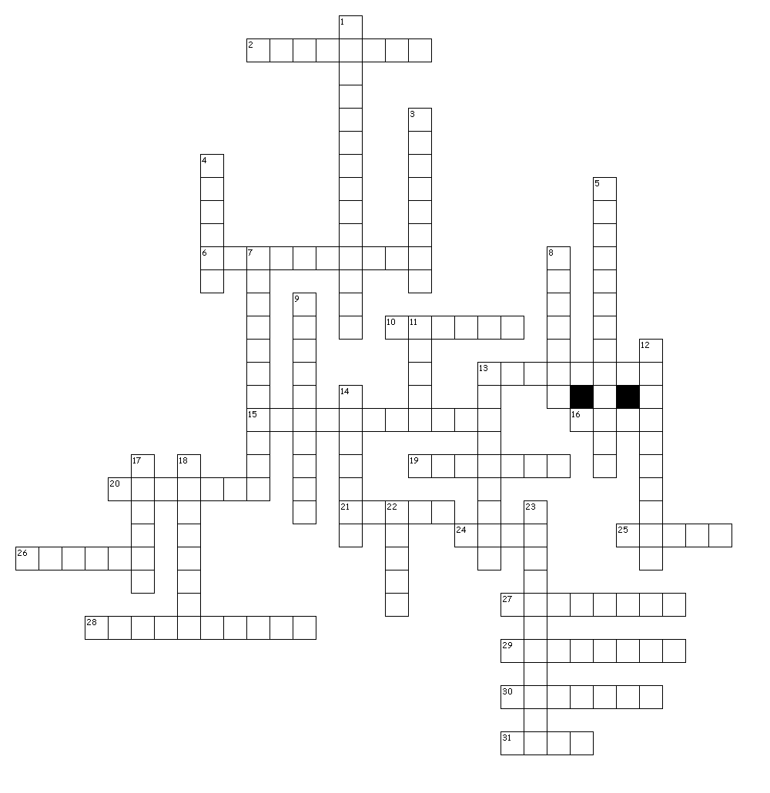

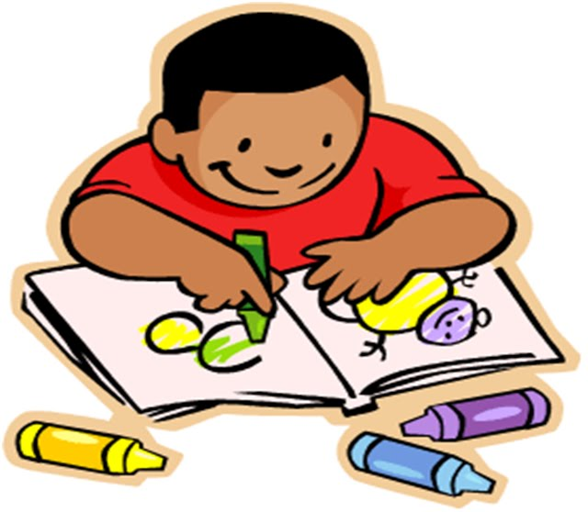
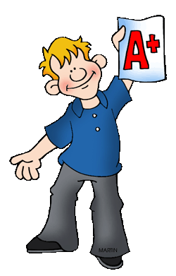



Across
2. ERASER
6. DESK
10. CRAYON
13. TRASH CAN
15. DICTIONARY
16. CHALK
19. SCISSOR
20. BOARD
21. CLOCK
24. GLUE
25. PENCIL
26. FILE
27. NOTEBOOK
28. HOLEPUNCH
29. MARKER
30. BACKPACK
31. MAP
Down
1. COLOR PENCILS
3. STAPLER
4. PAINTBRUSH
5. TAPE
7. COMPUTER
8. PAPERS
9. SCHOOL BUS
11. RULER
12. SHARPENER
13. PROJECTOR
14. PAINT
17. BELL
18. PEN
22. BOOK
23. CALCULATOR

